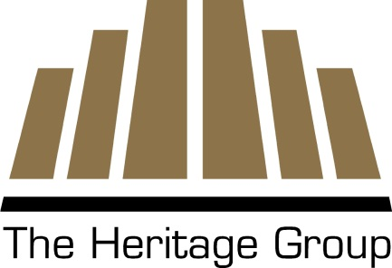
Environmental Engineer

The Environmental Engineer supports project managers and project engineers in the planning and execution of hazardous waste remediation engineering; industrial wastewater design; general process engineering; optimization of active remedial system; and planning, executing, and reporting long-term monitoring sampling events. Work for this position may include:

- Assisting with environmental engineering projects, including feasibility studies, remedial designs, and preparation of other related documentation and reports;
- Assisting with the preparation of design packages including engineering calculations, design sheets, specifications, and competitive bid procurement;
- Assisting with the execution of long-term monitoring projects including the development of sampling plans, work plans, participation on field investigation teams that include groundwater and soil sampling;
- Assisting with optimization and redesign of operating treatment systems;
- Supporting environmental treatment system operations and maintenance staff, and
- Preparation of a wide variety of plans and reports.

Candidate should have a proven record of delivering high-quality, on schedule written work products (plans and reports) within established budgets. Applicable work experience should include environmental treatment system design and operational support, hands-on multi-media sampling (soil, groundwater, surface water, sediment, indoor air, etc.), and report writing. The engineer should be self-motivated and able to work on moderately complex engineering projects. This position is located in Indianapolis, IN and requires travel for field assignments.

Requirements:

- M.S. or Ph.D. in Environmental Engineering
- At least 5 years’ experience in the environmental field with emphasis on Wastewater Treatment.
  - FBBR, MBBR, and AOP experience a plus.
- Strong chemistry background
- Excellent verbal and written communication skills.
- Ability to travel overnight for field assignments for a week or more at a time.
- OSHA 40-hour HAZWOPER training and up-to-date 8-hour refresher.
- Strong technical writing, organizational, and communication skills.
- Excellent computer skills including MS Word™, MS Excel™, and MS Project™.
- Ability to balance the needs of multiple concurrent projects while meeting all schedule, quality and safety requirements.

The ideal candidate will also have the following qualifications/experience:

- PE License or Engineer in Training Certification (EIT).
- Basic CAD and GIS skills.
- Experience with DoD environmental investigation and remediation projects

The Company:
The Heritage Research Group is a team of engineers, scientists and technicians that support the activities of the Heritage Group. For over 80 years, The Heritage Group (THG) has managed a diverse set of prominent companies involved in the highway construction, environmental services, oil refining & specialty chemicals industries and fuel distribution industry. This vast experience combined with a team management style, allows for the diversity of a large conglomerate and the personal service of a smaller, customer-focused organization. THG is a growth-oriented company with operations in North America, Europe and Asia and a customer network that spans the globe. As a family-owned business, a long-term financial approach and conservative investment philosophy has placed THG on a solid foundation to pursue growth opportunities as they appear. The organization has a creative culture, always searching for opportunities and researching industry-changing solutions. The company has grown impressively over the past 30 years both organically and by acquisition, often turning around distressed businesses.

THG's growth has been enabled by a positive culture comprised of the following characteristics: entrepreneurial and decentralized, lean and nimble, informal and non-hierarchical, loyal and supportive. THG is a builder of businesses and is well positioned financially to continue to grow effectively.

As a company, we look for individuals that demonstrate strength in Intuition and Analysis, Making an Impact and Working with Others.

Our Mission:
We turn big challenges into even bigger opportunities.
We're a family of relationship builders,
problem solvers and opportunity-seekers
who aim to make a difference in the world.
What We Do:
We have the unique ability to combine diverse assets and capabilities in inventive
ways to solve tough problems.
How We Serve:
We're always asking "what can we do better and different?"
And "what aren't we doing that we should be doing?"
Through ongoing action and dialogue,
and a lot of patience, we continuously pursue
the chance to build long-term value for all involved.

